EXPERIMENT 2

1. Command to determine login shell
2. Find available shells in the system
3. Use of/etc/passwd

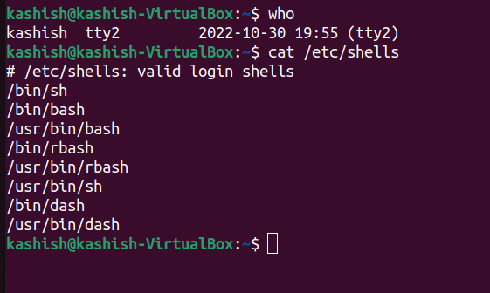

1. Date and who in line , date is displayed on output and who redirected to file

